Arc-Ghost Dance-Arapaho

Photographs by James Mooney 1890

http://www.ghostdance.com/cgi-bin/display/image.cgi?iid=37&itid=4

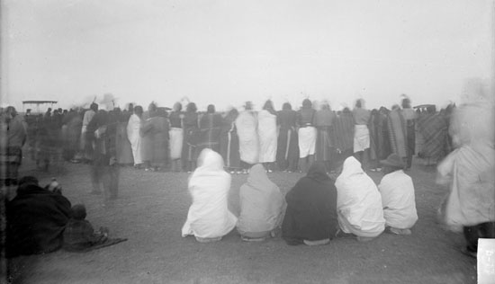 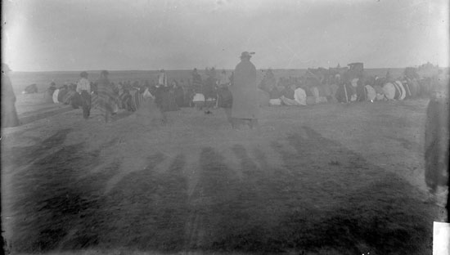 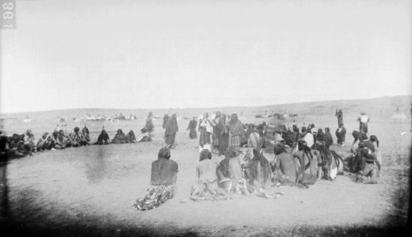 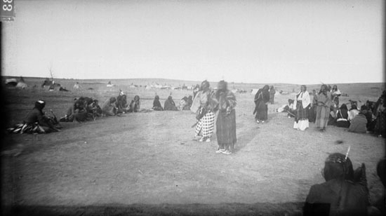 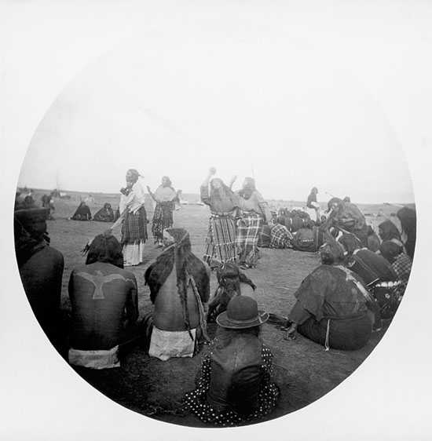 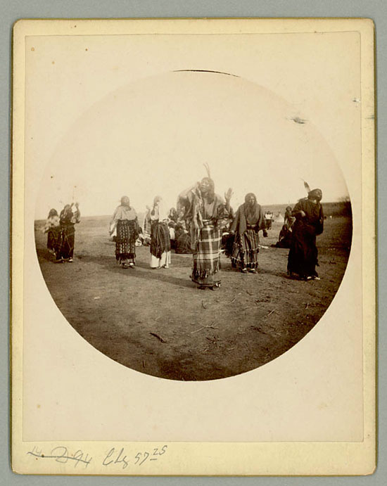 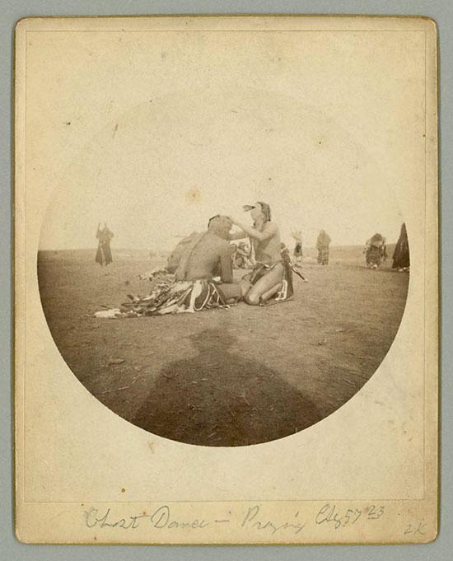 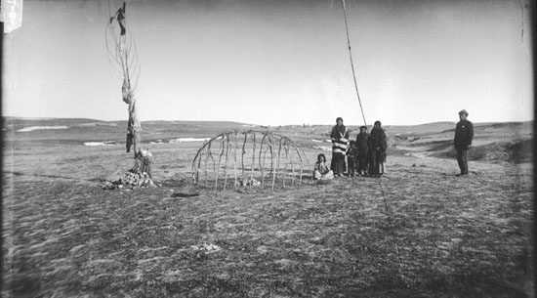

**Sweat lodge frame and sacrificial pole used for Ghost Dance**

Sweat lodge frame and sacrificial pole used for Ghost Dance, Pine Ridge, South Dakota (1892)

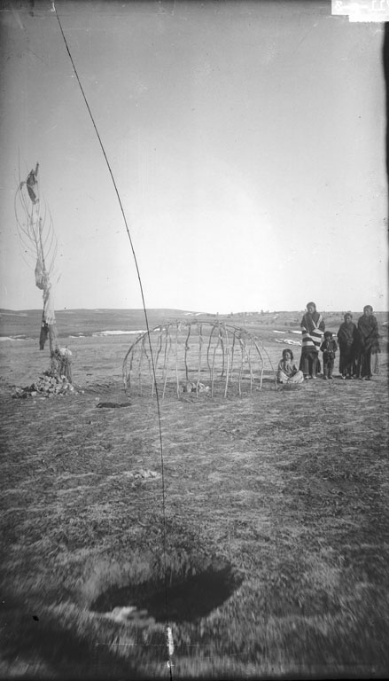

**Sweat lodge frame and sacrificial pole used for Ghost Dance**

Sweat lodge frame and sacrificial pole used for Ghost Dance, Pine Ridge, South Dakota (1892)

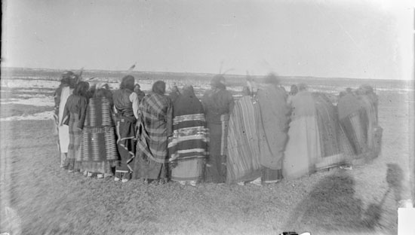

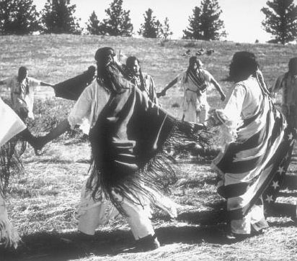

**Women Ghost Dancing**

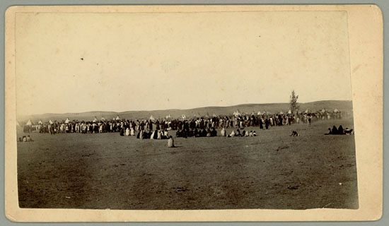

**Pine Ridge Reservation Ghost Dance**

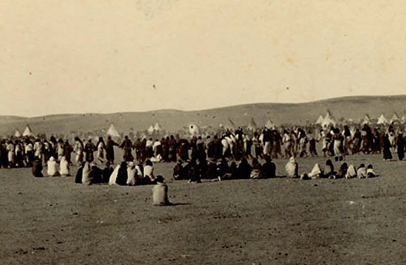

**Pine Ridge Reservation Ghost Dance (detail)**

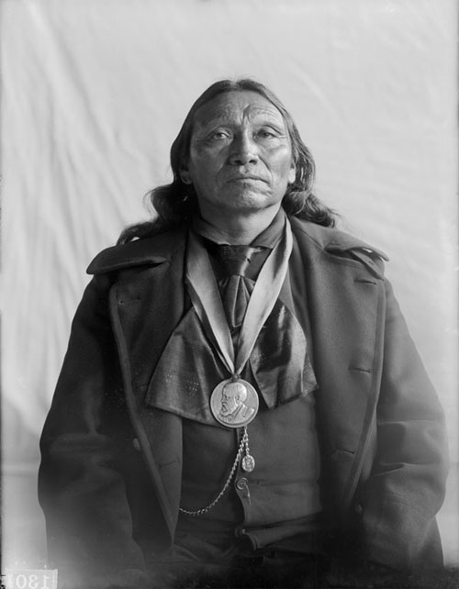

**Watangaa (Black Coyote)**

Watangaa (Black Coyote), Captain of Native Police, School Commissioner, Deputy U S Sheriff and Marshall, Leader of Ghost Dance, with Benjamin Harrison Peace Medal 21 JAN 1898

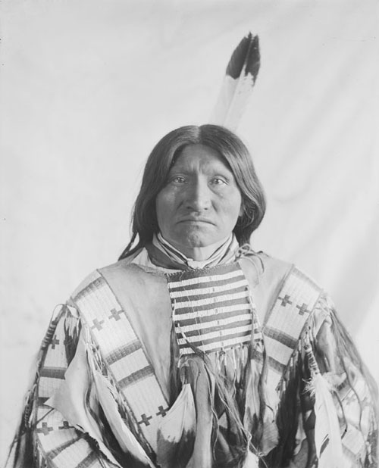

**Mato-Wa-Nahtaka (Kicking Bear)**

Mato-Wa-Nahtaka (Kicking Bear), Former Chief High Priest of the Ghost Dance, in Native Dress with His Scalp Shirt 1896

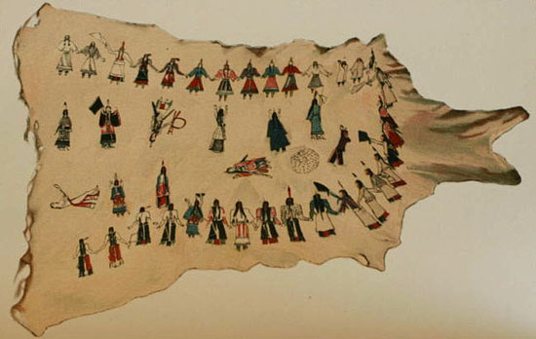

**Ghost Dance Painting on Buckskin**

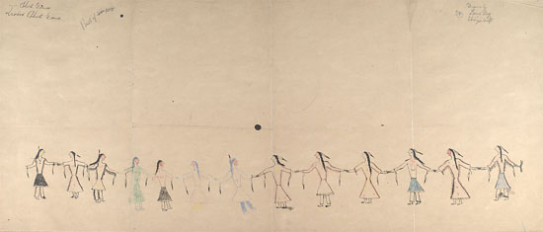

**Lame Dog drawing of Ghost Dance ceremony**

Lame Dog drawing of Ghost Dance ceremony, with line of men and women holding hands, ca. 1903?

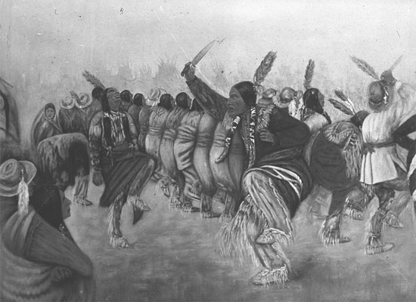

**Kiowa Ghost Dance Painting**

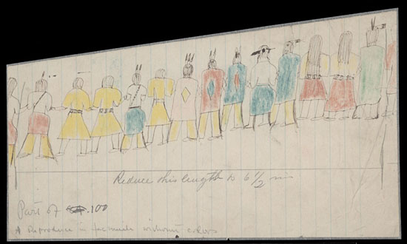

**Comanche drawing of Ghost Dance ceremony**

Anonymous Comanche drawing of Ghost Dance ceremony, with line of men and women holding hands, shown in rear view ca. 1903?

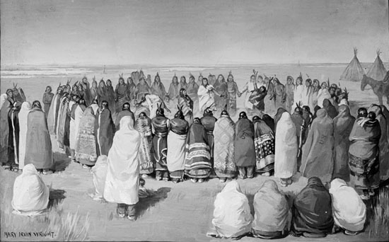

**Ghost Dance - Large Circle** [Mary Irvin Wright](http://www.ghostdance.com/cgi-bin/display/imagethumbs.cgi?itid=3) 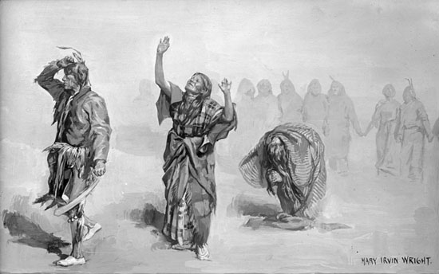

**Ghost Dance - Inspiration**

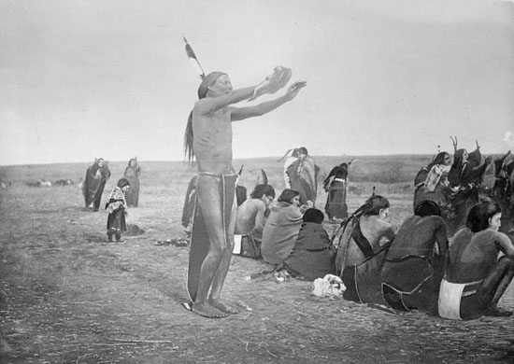

**Ghost Dance - Rigid**